1. Please Download the VPN setup from given below link for Winows based system.
2. https://forticlient.com/downloads

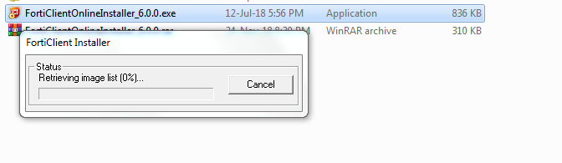

1. It will download the latest version of Fort client installer

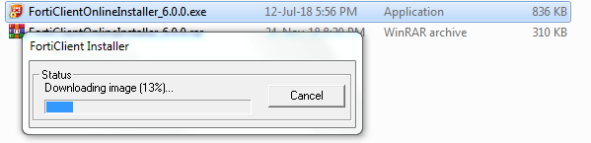

1. Install the software once download is complete.

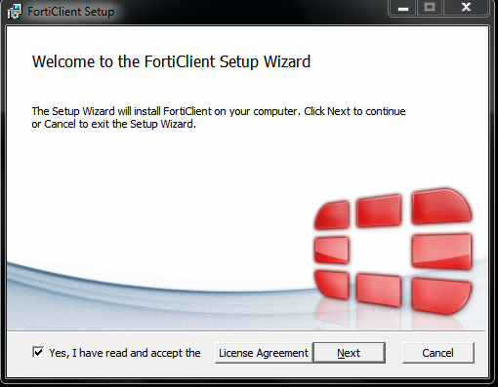

1. Select Secure remote access and give -🡪next -🡪 next --🡪 install.

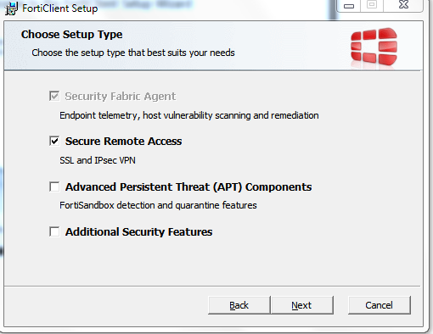

1. After finishing the installation new pop-up will show as below.

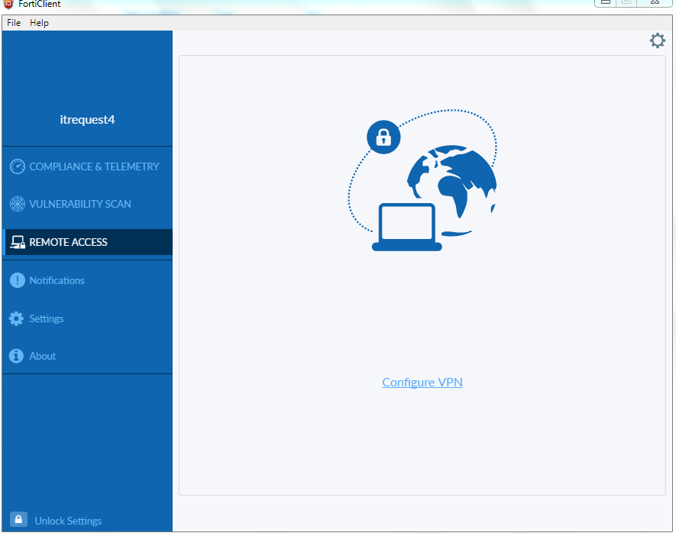

1. Click Configure VPN and Fill the following IP and port details which shared in mail.

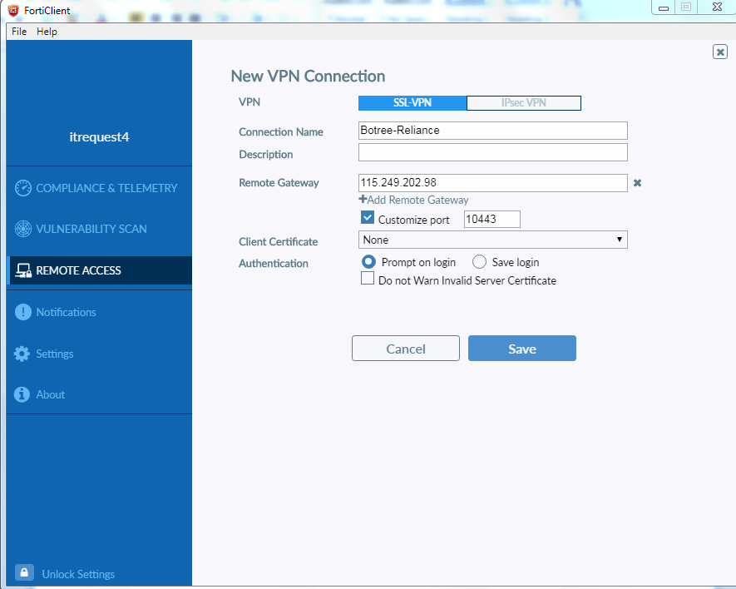

1. Save the configuration and it prompt to ask username and Pwd of VPN

